**APPLICATION FORM**

**INTERNATIONAL “COOKING – PASTRY”**

**COMPETITION**

**14th EDITION – 28 APRIL 2025**

DOCUMENTS TO ENCLOSE WITH THE APPLICATION:

BY 24 FEBRUARY, 00:00:

Please return the completed application form, together with all the required documents, to the following address: contact@trophee-mille.fr. An e-mail confirming receipt of your complete application will be sent to you as confirmation of your registration.

* Description sheet
* Measurement form, completed by candidates who do not know their Bragard jacket size (one form per person)
* Measurement form, completed by the accompanying teacher if he/she does not know his/her jacket size at Bragard
* Image rights completed by both candidates
* Image rights completed by the accompanying teacher
* Valid school certificates for both candidates
* A photo of the candidates taking part, with recommendations to be found on page 9
* Description of the savoury recipe with a photo of the savoury dish on a white plate
* Description of the sweet recipe with a photo of the sweet dish on a white plate

Desired quantities of required products :

* Brook trout: 4 pieces
* Celeriac: ...... kg
* Rambour apple: ...... kg
* Walnut oil: ...... 25 cl bottle(s)

**We ask you to use the layouts suggested in this registration pack, by filling in this document directly on the computer and not by hand to avoid any legibility errors. All documents must be sent in Word (not pdf, excel or png) and photos in JPEG or PNG (no scans or pdf), to facilitate the layout of your file for the day of the competition.**

DESCRIPTION FORM

THE ESTABLISHMENT

Surname - First name of director:

Postal address:

Country:

Telephone number:

E-mail:

School's social networks:

|  |  |
| --- | --- |
|  | Head of Teaching or Teaching Activity |
| Last name |  |
| First name |  |
| Mobile phone number |  |
| E-mail |  |

Signature of the school director:

ACCOMPANYING

|  |  |
| --- | --- |
|  | ACCOMPANYING |
| Male / Female |  |
| Last name |  |
| First name |  |
| Postal address |  |
| Zip or postal code |  |
| City |  |
| Country |  |
| Mobile phone number |  |
| E-Mail |  |
| Jacket size (if you don't know your Bragard size, please fill in the size form below). |  |

CANDIDATE TEAM

|  |  |  |
| --- | --- | --- |
|  | **FEMALE CANDIDATE** | **MALE CANDIDATE** |
| Last name |  |  |
| First name |  |  |
| Address |  |  |
| Zip or postal code |  |  |
| City |  |  |
| Country |  |  |
| Date of birth |  |  |
| Mobile phone number |  |  |
| E-mail |  |  |
| Facebook and Instagram (Not required) |  |  |
| Bragard jacket size or measurement sheet to be completed |  |  |

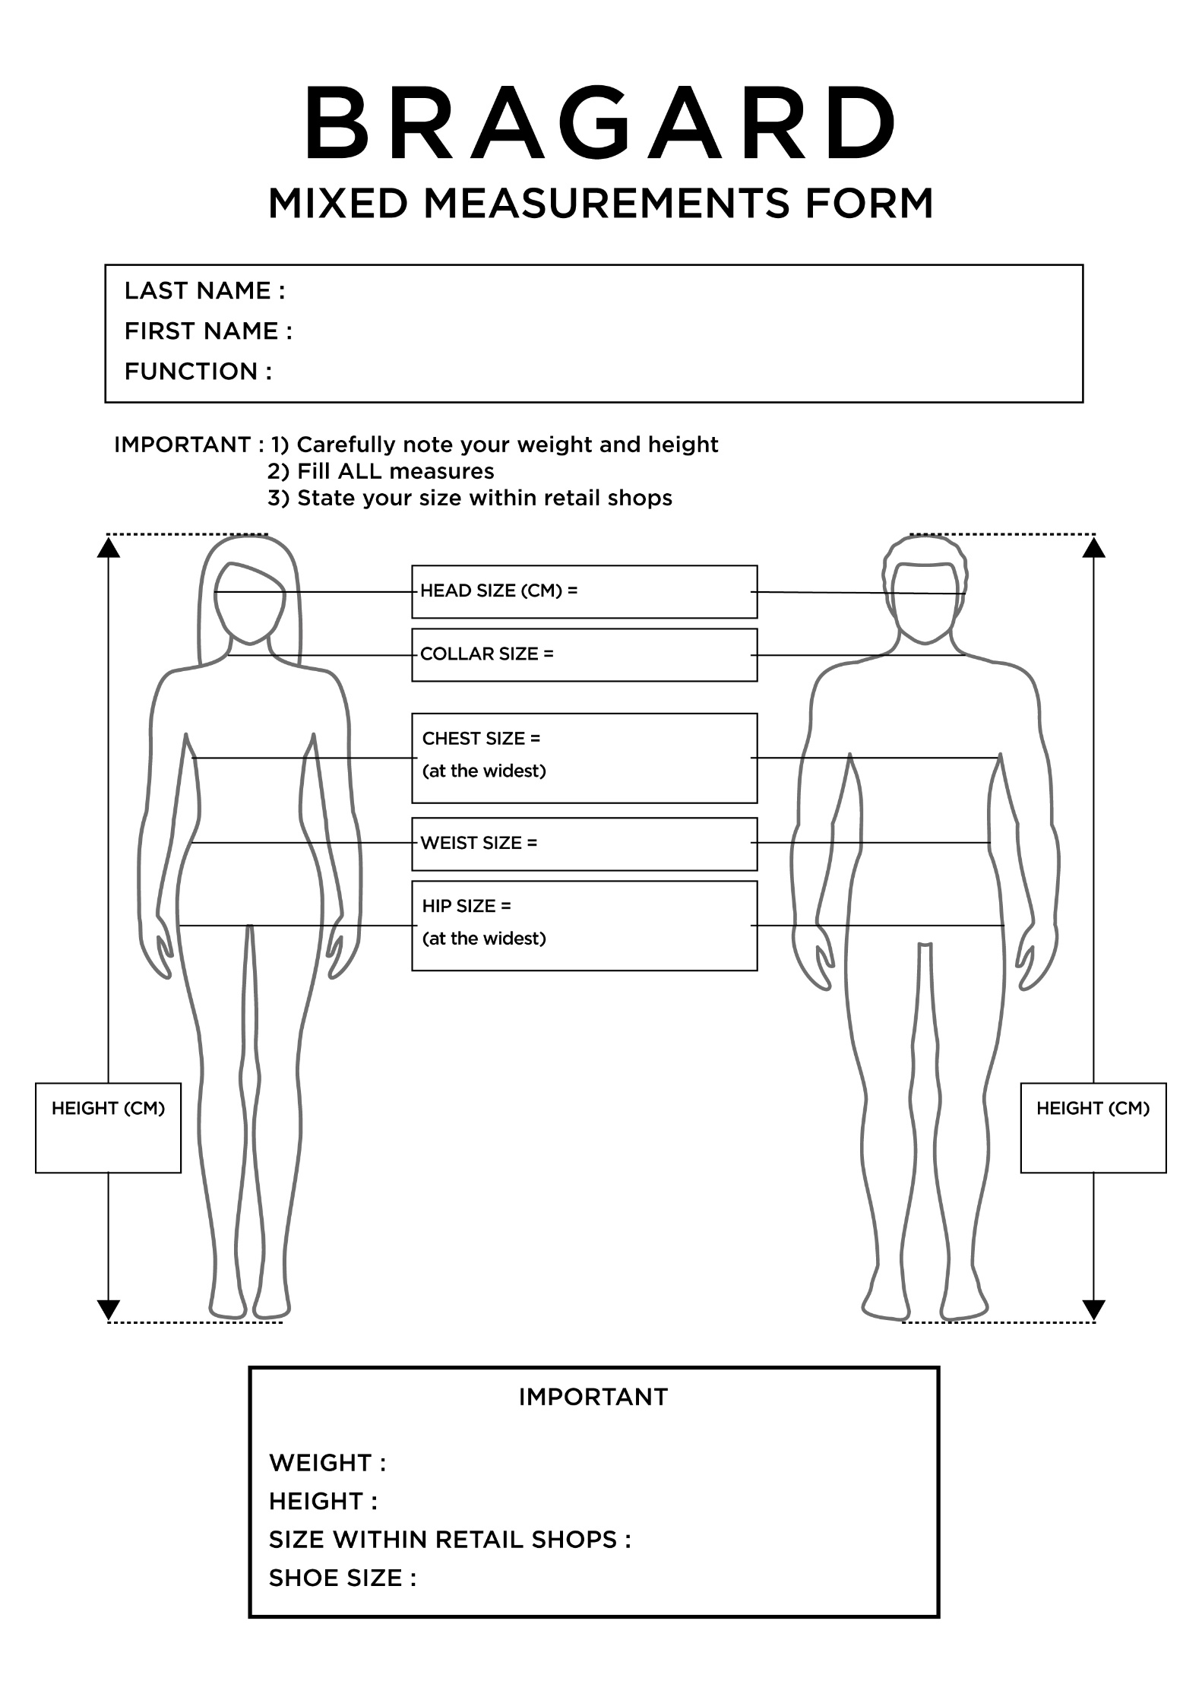

IMAGE RIGHT - ADULT

**Object: Permission to take and use pictures and videos of you to communicate and promote the contest and our gastronomic heritage.**

Dear Sir, Dear Madame,

Under the Trophée MILLE, international challenge of promotion of gastronomic heritage of the Grand Est region, photos and videos will be taken to enable the Trophée MILLE association, the Grand Est region, countries and institutions that have returned their act of commitment and contest participants to communicate and promote to the public, the regional heritage through different media and/or during regional, national or international events.

The Trophée MILLE association, medias, Grand Est region and institutions would like to have your permission to take pictures and videos of you.

The pictures and/or videos may be communicated to other persons, as mentioned above. It will be forbidden to either sell or use the pictures and/or videos for any other utilization than the following ones: to communicate, promote and value the gastronomic heritage and our contest.

In accordance with the law, the free access to photographical data and to video data concerning yourself is guaranteed. You will be able at any time to verify the utilization that is made with them and to have the right of withdrawal of these pictures and/or videos if there is any other utilization than: to communicate and promote the gastronomic heritage and our event.

In consequence, could you complete the form bellow, giving us the permission to make and use pictures and videos of you such as mentioned above?

We thank you in advance for your collaboration.

**Madam, Mister (Last name/First name):**

**Position:**

**School:**

Authorizes the Trophée Mille association, the Grand Est region, countries and institutions to:

- Take pictures and make videos of me;

-Stock and use these pictures;

-Copy and broadcast these pictures and videos during campaigns of communication and promotion of the Trophée MILLE

In ……………………………………………………………., on the ………………………………………………………

Signature: ………………………………………………………

IMAGE RIGHT - MINOR

**Object: Permission to take and use pictures and videos of your child to communicate and promote the contest and our gastronomic heritage.**

Dear Sir, Dear Madame,

Under the Trophée MILLE, international challenge of promotion of gastronomic heritage of the Grand Est region, photos and videos will be taken to enable the Trophée MILLE association, the Grand Est region, countries and institutions that have returned their act of commitment and contest participants to communicate and promote to the public, the regional heritage through different media and/or during regional, national or international events.

The Trophée MILLE association, medias, Grand Est region and institutions would like to have your permission to take pictures and videos of your child.

The pictures and/or videos may be communicated to other persons, as mentioned above. It will be forbidden to either sell or use the pictures and/or videos for any other utilization than the following ones: to communicate, promote and value the gastronomic heritage and our contest.

In accordance with the law, the free access to photographical data and to video data concerning your child is guaranteed. You will be able at any time to verify the utilization that is made with them and to have the right of withdrawal of these pictures and/or videos if there is any other utilization than: to communicate and promote the gastronomic heritage and our event.

In consequence, could you complete the form bellow, giving us the permission to make and use pictures and videos of your child such as mentioned above?

We thank you in advance for your collaboration.

**Mister (Father or Tutor):**

**Madam (Mother or Tutor):**

**Legal representative of the student (Last name/ First name):**

Authorizes the Trophée Mille association, the Grand Est region, countries and institutions to:

- Take pictures and make videos of this child

- Stock and use these pictures and videos

- Copy and broadcast these pictures and videos during campaigns of communication and promotion of the Trophée MILLE

(Father or Tutor) (Mother or Tutor)

(Signature) (Signature)

In ……………………………………………. In …………………………………………………

On the ……………………………………. On the …………………………………………...

EXAMPLE PHOTO OF CANDIDATES

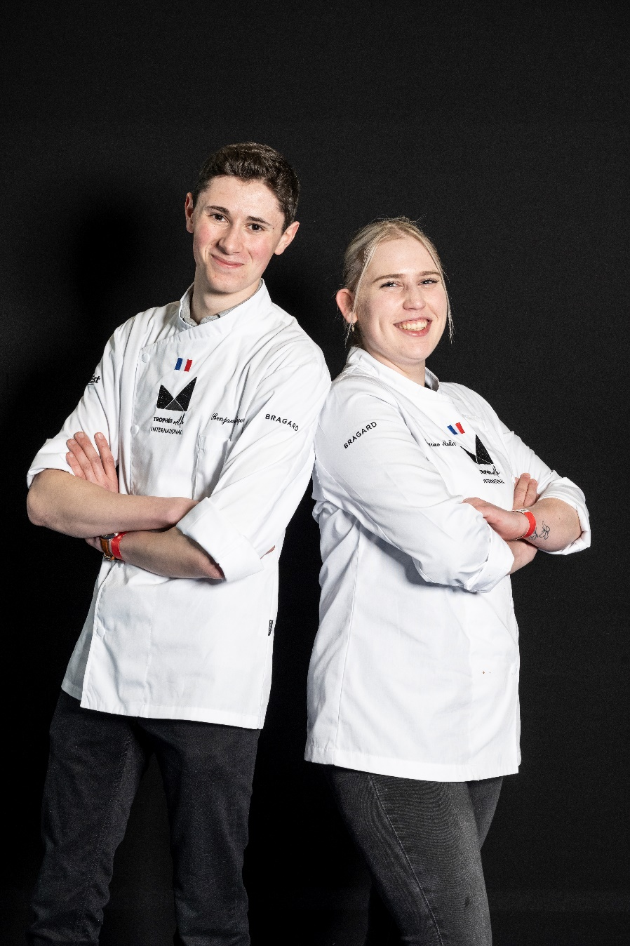

**Recommendations :**

* No chef's hat
* School uniform required
* Colour photo, not B&W
* Photo taken in landscape format
* The photo should preferably be taken against a white (or plain) background.
* For the positioning of the arms, candidates must cross their arms below their chest.
* Photo frame: cut off the photo at hip level

EXAMPLE OF A RECIPE DESCRIPTION

**Please send us your recipe sheets in editable Word format by 24 February 2025, so that we can standardize**

**all the candidates' files for the day of the competition.**

RECIPE SHEET – SALTY DISH

**Recipe title – 24 words maximum**:

Duck breast from the Tilloy farm, saffron-flavoured puffed apples from the Albert apiary, shallots and Medjool dates, reduced juice.

**Ingredients for 4 people**:

***Please give the complete, uniform list in the form of a list and not a table. Do not divide the list according to the stages in the cooking process.***

2 duck breasts from the Tilloy farm

2 duck legs

20cl whipping cream

1 jar of saffron honey

500 gr AGRIA potatoes

16g white vinegar

150g baby spinach

100 g lard de Collo nata

2 sheets of Nori

250 gr Asperge Verte

25 g Brined pepper

PM Wine Vinegar

30 g tapioca starch

PM Agar Agar

PM Gelan

150g duck fat

6 Medjool dates

2 citrons Primofiori

100g butter

1 carrot

1 onion

1/2L light veal stock

1 bunch of fresh thyme

2 bay leaves

25g fennel seeds

25g coriander seeds

25g cumin seed

10g ground fennel seeds

1/2 bunch of fresh cilantro

3 shalves

75g pork belly

75g chicken livers

10cl cognac

20cl olive oil

10gr of transglutaminase (meat glue)

PM sel fin

**Description – 400 words maximum, including dressing**:

Throw the bottom with the boneless and fat-free thighs and with the carrot and onion cut into mirepoix. Trim the fat from the duck breasts, score them and insert the rolled asparagus into the colonata, stick them together and make the stuffing with the trimmings and cream. Spread a thin layer, add the duck breasts and steam. Cut the skin into cubes and brown in a sauté pan.

Make a tuile with the tapioca flour and water, steam and cook in dry heat. Cook the shallots and lemons en foilote. Collect the lemon pulp, cut off part of the peel and blend and strain through a sieve. Make a green purée with the baby spinach.

Make a charcuterie stuffing with the pork belly and livers, then add the minced thigh flesh with a knife. Peel the dates, stuff with lemon paste, poach the stuffing on top of the date and add a layer of shallot, roll into a ballottine and steam. Cut the potato into mixtures, cook in water for 30 seconds, mix and add the powders, spread on silpat, dehydrate for 45 minutes at 110°. Rehydrate in a steam oven, glue the leaves together, and fry. Cut the asparagus with a mandolin, glaze, make a saffron honey vinaigrette and season the tips with it.

Make an infusion with the shallot scraps, filter, stick, season, add a brunoise of confit thigh, pour on a tray.

Streak the stuffing of the duck breasts with a knife, sear and drizzle with duck fat.

Make a shallot, red wine and green pepper reduction for the deviled juice.

**Dressage: Please specify how you would like your recipe to be presented to accompany the photo of the dish.**

To serve, make a circle with chlorophyll, place the warmed date in duck stock and glossy at the top left of the plate. Decorate with tile and flowers. Place the veil on top of the puffed apple and stuff it with green asparagus tips, decorate with flowers. Slice the duck breast into four equal parts, add the seeds and fleur de sel, place it on the right side of the plate.

Pour the hot sauce into the center.

