**APPLICATION FORM**

**INTERNATIONAL « SERVICE – SOMMELIER »**

**COMPETITION**

**15th EDITION – MARCH 2026**

DOCUMENTS TO ENCLOSE WITH THE APPLICATION:

BY 13 FEBRUARY, 00H00:

Please return the completed application form, together with all the required documents, to the following address: [contact@trophee-mille.fr](mailto:contact@trophee-mille.fr) An e-mail confirming receipt of your complete application will be sent to you as confirmation of your registration.

* Description sheet
* Measurement form, completed by candidates who do not know their Bragard waistcoat size (one form per person)
* Image rights completed by both candidates
* Image rights completed by the accompanying teacher
* Valid school leaving certificate for both candidates
* Photocopy of the identity card or passport of both candidates
* A photo of the participating candidates, with recommendations to be found on page 10
* Text in English of 250 words written in Word format by the team, on the theme ‘Are restaurant service and sommellerie complementary professions?’.
* **Tablecloth chosen:**

**We ask you to use the layouts suggested in this registration pack, by filling in this document directly on the computer and not by hand to avoid any legibility errors. All documents must be sent in Word (not pdf, excel or png) and photos in JPEG or PNG (no scans or pdf), to facilitate the layout of your file for the day of the competition.**

DESCRIPTION FORM

THE ESTABLISHMENT

Country:

Name of establishment:

Last name - First name of director:

Postal address:

Telephone number:

E-mail:

School's social networks:

|  |  |
| --- | --- |
|  | Head of Teaching or Teaching Activity |
| Last name |  |
| First name |  |
| Telephone number |  |
| E-mail |  |

Signature of school director:

ACCOMPANYING

|  |  |
| --- | --- |
|  | ACCOMPANYING |
| Male / Female |  |
| Last name |  |
| First name |  |
| E-mail |  |
| Postal code |  |
| City |  |
| Country |  |
| Telephone number |  |
| E-Mail |  |

CANDIDATE TEAM

|  |  |  |
| --- | --- | --- |
|  | **SERVICE CANDIDATE** | **SOMMELIER CANDIDATE** |
| Male / Female |  |  |
| Last name |  |  |
| First name |  |  |
| Address |  |  |
| Postal code |  |  |
| City |  |  |
| Country |  |  |
| Date of birth |  |  |
| Telephone number |  |  |
| E-mail |  |  |
| Facebook and Instagram (**Not required)** |  |  |
| Bragard waistcoat size or measurement sheet to be completed |  |  |

SERVICE – SOMMELIER TESTS

The competition tests will be run separately: a service section and a sommelier section, each comprising 4 different tests. A final test, common to both candidates, will be carried out as a team.

Service tests :

* Cutting
* Service of cheeses from the Grand Est region
* Table arts
* Buckling creation

Sommelier tests :

* Presentation of champagnes
* Written questionnaire
* Decanting
* Order taking

Common test for both candidates :

* Carré des Producteurs

IMAGE RIGHT - ADULT

**Object: Permission to take and use pictures and videos of you to communicate and promote the contest and our gastronomic heritage.**

Dear Sir, Dear Madame,

Under the Trophée MILLE, international challenge of promotion of gastronomic heritage of the Grand Est region, photos and videos will be taken to enable the Trophée MILLE association, the Grand Est region, countries and institutions that have returned their act of commitment and contest participants to communicate and promote to the public, the regional heritage through different media and/or during regional, national or international events.

The Trophée MILLE association, medias, Grand Est region and institutions would like to have your permission to take pictures and videos of you.

The pictures and/or videos may be communicated to other persons, as mentioned above. It will be forbidden to either sell or use the pictures and/or videos for any other utilization than the following ones: to communicate, promote and value the gastronomic heritage and our contest.

In accordance with the law, the free access to photographical data and to video data concerning yourself is guaranteed. You will be able at any time to verify the utilization that is made with them and to have the right of withdrawal of these pictures and/or videos if there is any other utilization than: to communicate and promote the gastronomic heritage and our event.

In consequence, could you complete the form bellow, giving us the permission to make and use pictures and videos of you such as mentioned above?

We thank you in advance for your collaboration.

**Madam, Mister (Last name/First name):**

**Position:**

**School:**

Authorizes the Trophée Mille association, the Grand Est region, countries and institutions to:

- Take pictures and make videos of me;

-Stock and use these pictures;

-Copy and broadcast these pictures and videos during campaigns of communication and promotion of the Trophée MILLE

In ……………………………………………………………., on the ………………………………………………………

Signature: ………………………………………………………

IMAGE RIGHT - MINOR

**Object: Permission to take and use pictures and videos of your child to communicate and promote the contest and our gastronomic heritage.**

Dear Sir, Dear Madame,

Under the Trophée MILLE, international challenge of promotion of gastronomic heritage of the Grand Est region, photos and videos will be taken to enable the Trophée MILLE association, the Grand Est region, countries and institutions that have returned their act of commitment and contest participants to communicate and promote to the public, the regional heritage through different media and/or during regional, national or international events.

The Trophée MILLE association, medias, Grand Est region and institutions would like to have your permission to take pictures and videos of your child.

The pictures and/or videos may be communicated to other persons, as mentioned above. It will be forbidden to either sell or use the pictures and/or videos for any other utilization than the following ones: to communicate, promote and value the gastronomic heritage and our contest.

In accordance with the law, the free access to photographical data and to video data concerning your child is guaranteed. You will be able at any time to verify the utilization that is made with them and to have the right of withdrawal of these pictures and/or videos if there is any other utilization than: to communicate and promote the gastronomic heritage and our event.

In consequence, could you complete the form bellow, giving us the permission to make and use pictures and videos of your child such as mentioned above?

We thank you in advance for your collaboration.

**Mister (Father or Tutor):**

**Madam (Mother or Tutor):**

**Legal representative of the student (Last name/ First name):**

Authorizes the Trophée Mille association, the Grand Est region, countries and institutions to:

- Take pictures and make videos of this child

- Stock and use these pictures and videos

- Copy and broadcast these pictures and videos during campaigns of communication and promotion of the Trophée MILLE

(Father or Tutor) (Mother or Tutor)

(Signature) (Signature)

In ……………………………………………. In …………………………………………………

On the ……………………………………. On the …………………………………………...

EXAMPLE PHOTO OF CANDIDATES

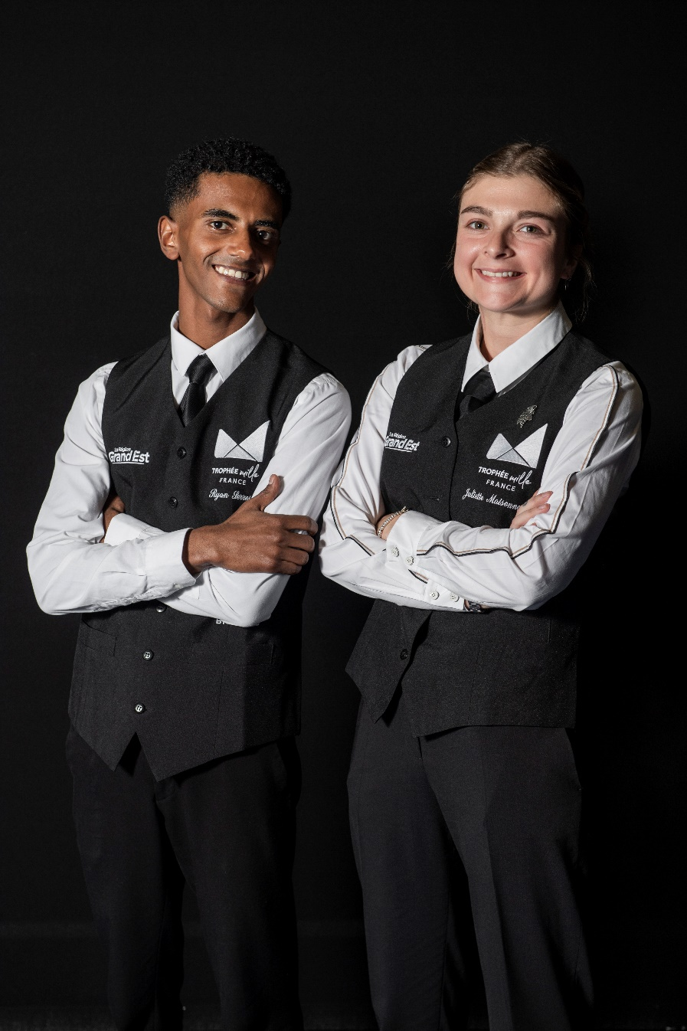

**Recommendations:**

* School uniform required
* Colour photo, not B&W
* Photo taken in landscape format
* The photo should preferably be taken against a white (or plain) background.
* For the positioning of the arms, candidates should cross their arms below their chest.
* Photo frame: cut off the photo at hip level