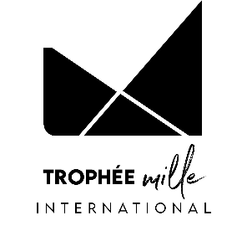



**APPLICATION FORM**

**INTERNATIONAL « COOKING-PASTRY »**

**COMPETITION**

**15ème EDITION – MARCH 2026**

DOCUMENTS TO ENCLOSE WITH THE APPLICATION:

BY 13 FEBRUARY, 00H00:

Please return the completed application form, together with all the required documents, to the following address: [contact@trophee-mille.fr](mailto:contact@trophee-mille.fr) An e-mail confirming receipt of your complete application will be sent to you as confirmation of your registration.

* Description sheet
* Measurement sheet, completed by the candidates who do not know their jacket size at Bragard (one sheet per person)
* Measurement sheet, completed by the accompanying teacher if he/she does not know his/her jacket size at Bragard
* Image rights completed by the two candidates
* Image rights completed by the accompanying teacher
* Valid school certificate for the 2 candidates
* Photocopy of the identity card or passport of the two candidates
* A photo of the participating candidates, with the recommendations on page 9
* Description of the savoury recipe with a photo of the savoury dish on a white plate
* Description of the sweet recipe with a photo of the sweet dish on a white plate

Desired quantities of required products :

- Guinea fowl: 1 piece

- Red onion: ...... kg

- Morgane pear: ...... kg

- Buckwheat flour: ...... 500g sachet(s)

**We ask you to use the layouts suggested in this registration pack, by filling in this document directly on the computer and not by hand to avoid any legibility errors. All documents must be sent in Word (not pdf, excel or png) and photos in JPEG or PNG (no scans or pdf), to facilitate the layout of your file for the day of the competition.**

DESCRIPTION FORM

THE ESTABLISHMENT

Country:

Name of establishment:

Last name - First name of director:

Postal address:

Telephone number:

E-mail:

School's social networks:

|  |  |
| --- | --- |
|  | Head of Teaching or Teaching Activity |
| Last name |  |
| First name |  |
| Telephone number |  |
| E-mail |  |

Signature of school director:

ACCOMPANYING

|  |  |
| --- | --- |
|  | ACCOMPANYING |
| Male / Female |  |
| Last name |  |
| First name |  |
| E-mail |  |
| Postal code |  |
| City |  |
| Country |  |
| Telephone number |  |
| E-Mail |  |

CANDIDATE TEAM

|  |  |  |
| --- | --- | --- |
|  | **CANDIDATE** | **CANDIDATE** |
| Male / Female |  |  |
| Last name |  |  |
| First name |  |  |
| Address |  |  |
| Postal code |  |  |
| City |  |  |
| Country |  |  |
| Date of birth |  |  |
| Telephone number |  |  |
| E-mail |  |  |
| Facebook and Instagram (**Not required)** |  |  |
| Bragard waistcoat size or measurement sheet to be completed |  |  |

IMAGE RIGHT - ADULT

**Object: Permission to take and use pictures and videos of you to communicate and promote the contest and our gastronomic heritage.**

Dear Sir, Dear Madame,

Under the Trophée MILLE, international challenge of promotion of gastronomic heritage of the Grand Est region, photos and videos will be taken to enable the Trophée MILLE association, the Grand Est region, countries and institutions that have returned their act of commitment and contest participants to communicate and promote to the public, the regional heritage through different media and/or during regional, national or international events.

The Trophée MILLE association, medias, Grand Est region and institutions would like to have your permission to take pictures and videos of you.

The pictures and/or videos may be communicated to other persons, as mentioned above. It will be forbidden to either sell or use the pictures and/or videos for any other utilization than the following ones: to communicate, promote and value the gastronomic heritage and our contest.

In accordance with the law, the free access to photographical data and to video data concerning yourself is guaranteed. You will be able at any time to verify the utilization that is made with them and to have the right of withdrawal of these pictures and/or videos if there is any other utilization than: to communicate and promote the gastronomic heritage and our event.

In consequence, could you complete the form bellow, giving us the permission to make and use pictures and videos of you such as mentioned above?

We thank you in advance for your collaboration.

**Madam, Mister (Last name/First name):**

**Position:**

**School:**

Authorizes the Trophée Mille association, the Grand Est region, countries and institutions to:

- Take pictures and make videos of me;

-Stock and use these pictures;

-Copy and broadcast these pictures and videos during campaigns of communication and promotion of the Trophée MILLE

In ……………………………………………………………., on the ………………………………………………………

Signature: ………………………………………………………

IMAGE RIGHT - MINOR

**Object: Permission to take and use pictures and videos of your child to communicate and promote the contest and our gastronomic heritage.**

Dear Sir, Dear Madame,

Under the Trophée MILLE, international challenge of promotion of gastronomic heritage of the Grand Est region, photos and videos will be taken to enable the Trophée MILLE association, the Grand Est region, countries and institutions that have returned their act of commitment and contest participants to communicate and promote to the public, the regional heritage through different media and/or during regional, national or international events.

The Trophée MILLE association, medias, Grand Est region and institutions would like to have your permission to take pictures and videos of your child.

The pictures and/or videos may be communicated to other persons, as mentioned above. It will be forbidden to either sell or use the pictures and/or videos for any other utilization than the following ones: to communicate, promote and value the gastronomic heritage and our contest.

In accordance with the law, the free access to photographical data and to video data concerning your child is guaranteed. You will be able at any time to verify the utilization that is made with them and to have the right of withdrawal of these pictures and/or videos if there is any other utilization than: to communicate and promote the gastronomic heritage and our event.

In consequence, could you complete the form bellow, giving us the permission to make and use pictures and videos of your child such as mentioned above?

We thank you in advance for your collaboration.

**Mister (Father or Tutor):**

**Madam (Mother or Tutor):**

**Legal representative of the student (Last name/ First name):**

Authorizes the Trophée Mille association, the Grand Est region, countries and institutions to:

- Take pictures and make videos of this child

- Stock and use these pictures and videos

- Copy and broadcast these pictures and videos during campaigns of communication and promotion of the Trophée MILLE

(Father or Tutor) (Mother or Tutor)

(Signature) (Signature)

In ……………………………………………. In …………………………………………………

On the ……………………………………. On the …………………………………………...

EXAMPLE PHOTO OF CANDIDATES

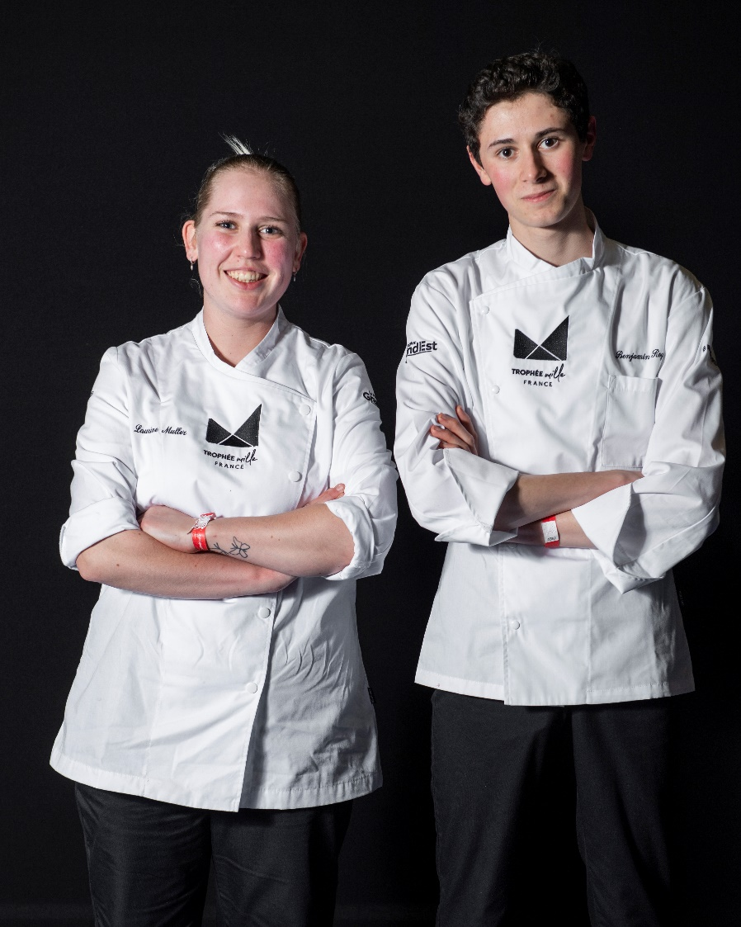

**Recommendations:**

* No chef's hat
* School uniform required
* Colour photo, not B&W
* Photo taken in landscape format
* The photo should preferably be taken against a white (or plain) background.
* For the positioning of the arms, candidates must cross their arms below their chest.
* Photo frame: cut off the photo at hip level

EXAMPLE OF A RECIPE DESCRIPTION

**Please send us your recipe sheets in editable Word format by 13 February 2026, so that we can standardise all the candidates' files for the day of the competition.**

SAVOURY RECIPE

**Recipe title – 24 words maximum** :

Duck breast from the Tilloy farm, saffron-flavoured puffed apples from the Albert apiary, shallots and Medjool dates, reduced juice.

**Ingredients for 4 people**:

***Please give the complete, uniform list in the form of a list and not a table. Do not divide the list according to the stages in the cooking process.***

2 duck breasts from Ferme de Tilloy

2 duck legs

20cl single cream

1 jar saffron honey

500g AGRIA potatoes

16g white vinegar

150g baby spinach

100g Collo nata bacon

2 Nori leaves

250g green asparagus

25g pepper brine

PM wine vinegar

30g tapioca starch

PM Agar Agar

PM Gelan

150g duck fat

6 Medjool dates

2 Primofiori lemons

100g butter

1 carrot

1 onion

½L light veal stock

1 bunch fresh thyme

2 bay leaves

25g fennel seeds

25g coriander seeds

25g cumin seeds

10g ground fennel seeds

½ bunch fresh coriander

3 shallots

75g pork belly

75g chicken livers

10cl cognac

20cl olive oil

10gr transglutaminase (meat glue)

PM fine salt

PM black pepper

PM saffron pistil

PM Flowers Decoration

**Recipe description - 400 words maximum, including presentation :**

Place the boneless, fat-free thighs and the carrot and onion in a mirepoix. Remove the fat from the duck breasts, score them and insert the rolled asparagus into the colonata, stick them together and make the stuffing with the trimmings and cream. Spread in a thin layer, add the duck breasts and steam. Cut the skin into cubes and brown in a pan. Make a tuile with the tapioca flour and water, steam and then cook over dry heat. Cook the shallots and lemons en papillote. Remove the lemon pulp, cut off some of the rind and blend, then sieve. Make a green purée with the baby spinach.

Make a charcuterie stuffing with the pork belly and livers, then add the meat from the thighs, chopped with a knife. Peel the dates, stuff with lemon paste, poach the stuffing over the dates and add a layer of shallots, roll into a ballottine and steam. Cut the potato into macedoine shapes, cook in water for 30 seconds, blend and add the powders, spread out on a silpat and dehydrate for 45 minutes at 110°. Rehydrate in a steamer, stick the leaves together and fry. Cut the asparagus with a mandolin, glaze, make a saffron honey vinaigrette and season the tips.

Make an infusion with the shallot trimmings, strain, glue, season, add a brunoise of confit leg and pour onto a platter. Strain the duck breast stuffing with a knife, sear and drizzle with duck fat. Make a shallot, red wine and green pepper reduction for the jus à la diable.

**Presentation: Please specify how you would like your recipe to be presented to accompany the photo of the dish.**

To serve, use the chlorophyll to make a circle and place the date, warmed in the duck stock and glossed, at the top left of the plate. Decorate with the tuile and flowers. Place the veil over the puffed apple and stuff with green asparagus tips, decorating with flowers. Slice the duck breast into four equal parts, add the seeds and fleur de sel and place on the right-hand side of the plate. Pour the hot sauce over the centre.

